SIMATS ENGINEERING (SAVEETHA SCHOOL OF ENGINEERING)
Department of Computer Science and Engineering
ASSESSMENT TOOL 1 – RAG-BASED MINI ASSIGNMENT (DOCUMENT QA / AI AGENT DEMO)

Course Code: | CSA65 | Course Title: | Generative AI and Large Language Models
CO Assessed: | CO3 – Precision (BL2, BL3) | Assessment: | Assessment Tool 2 – RAG-based Mini Assignment (Document QA / AI Agent Demo)
Weightage: | 20% of CIA | Total Marks: | 2 * 50 = 100 (1 Question1)
CO3 Statement: | Develop intelligent applications using Retrieval-Augmented Generation (RAG), vector databases, and introductory AI agent concepts.(BL3, BL4)
Student Name: | Surya Krishna Teja Yandra | Reg. No.: | 192425065
Section / Batch: | 2024 | Date: | 11-08-2026

Instructions to Students
- Answer 2 questions. Each question carries 50 marks.Total: 100 Marks.
· Implement the solution using Python.
· Use an appropriate LLM such as OpenAI, Gemini, or Hugging Face.
· Use embeddings and semantic search where applicable.
· Use FAISS or ChromaDB as the vector database for RAG tasks.
· Demonstrate the complete pipeline:
Document → Chunking → Embedding → Retrieval → Generation
· Demonstrate the system with multiple queries.
· Handle irrelevant, incomplete, or unsupported queries appropriately.
· Display retrieved context/source wherever applicable.
· Explain the system architecture.
· Provide a working end-to-end demonstration.

Code of Conduct
I Surya Krishna Teja Yandra/192425065 (Name / Reg No) certify that this submission is my original work and that I have adhered to the guidelines specified for this assessment. I understand that any violation of academic integrity rules will result in disciplinary action.
Signature of the Student: _________________________

SECTION A – RAG-BASED MINI ASSIGNMENT (DOCUMENT QA / AI AGENT DEMO)
2. Course Notes Question Answering: Create a Document QA system using course notes. Answer questions about paging, page tables, FIFO page replacement, virtual memory, or similar topics using the supplied notes.
5. Employee Policy QA System: Develop a RAG application using an employee policy document. Answer questions about leave, working hours, attendance, holidays, and benefits.
RUBRICS FOR CALCULATION
Criteria | Weightage | Level 4 – Exemplary | Level 3 – Proficient | Level 2 – Developing | Level 1 – Beginning
Pipeline Functionality | 30% | Correct RAG pipeline — embeddings, retrieval and generation all function coherently | Pipeline mostly correct with minor gaps | Pipeline only partially functional | Pipeline non-functional or conceptually flawed
Answer Relevance & Groundedness | 25% | Retrieves relevant context and generates accurate, grounded answers | Mostly relevant/accurate answers | Inconsistent relevance or accuracy | Answers largely irrelevant or hallucinated
Query Robustness | 20% | Robust handling of varied queries and documents | Handles most queries well | Handles only simple queries | Fails on basic queries
End-to-End Demo | 15% | Smooth, well-demonstrated end-to-end system | Demo mostly smooth, minor hiccups | Demo has noticeable issues | Demo fails or is not ready
Architecture Explanation | 10% | Clear architecture diagram and explanation of design decisions | Adequate explanation of design | Minimal explanation of design | No explanation of design provided

Marks Evaluation:
Question No. | Pipeline Functionality(30%) | Answer Relevance & Groundedness (25%) | Query Robustness(20%) | End-to-End Demo(15%) | Architecture Explanation (10%) | Total Marks (100)
Q1
Q2
Overall Total (100)

2)
1. Aim
- Create a Document Question Answering (QA) system using course notes.
- Use RAG (Retrieval-Augmented Generation) to answer questions from the supplied notes.
- Focus on topics such as:
  - Paging
  - Page tables
  - FIFO page replacement
  - Virtual memory
  - Page faults
2. Proposed RAG Pipeline
Course Notes → Text Extraction → Chunking → Embeddings → Vector Database → Retrieval → LLM → Grounded Answer
- Document: Upload course notes in PDF/TXT format.
- Chunking: Divide notes into smaller meaningful sections.
- Embeddings: Convert each chunk into numerical vectors.
- Vector Database: Store embeddings for similarity search.
- Query: User enters a question.
- Retrieval: Find the most relevant chunks from the notes.
- Generation: LLM generates an answer using retrieved content.
- Output: Display the answer along with the retrieved context/source.
3. Example Questions and Expected Answers
User Question | Expected Answer
What is paging? | Paging is a memory-management technique that divides logical memory into fixed-size pages and physical memory into frames.
What is a page table? | A page table maintains the mapping between logical pages and physical memory frames.
Explain FIFO page replacement. | FIFO replaces the page that has been in memory for the longest time.
What is virtual memory? | Virtual memory allows a system to use secondary storage as an extension of physical memory.
What is a page fault? | A page fault occurs when a required page is not currently present in physical memory.
Important: In the actual demo, these answers should be generated from the supplied course notes rather than hard-coded.

4. Architecture Diagram

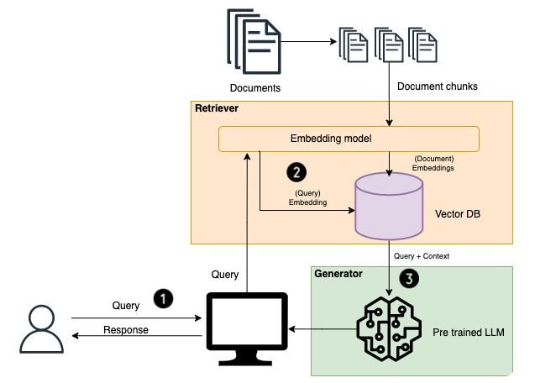
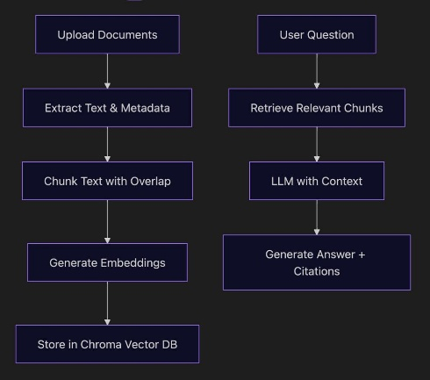
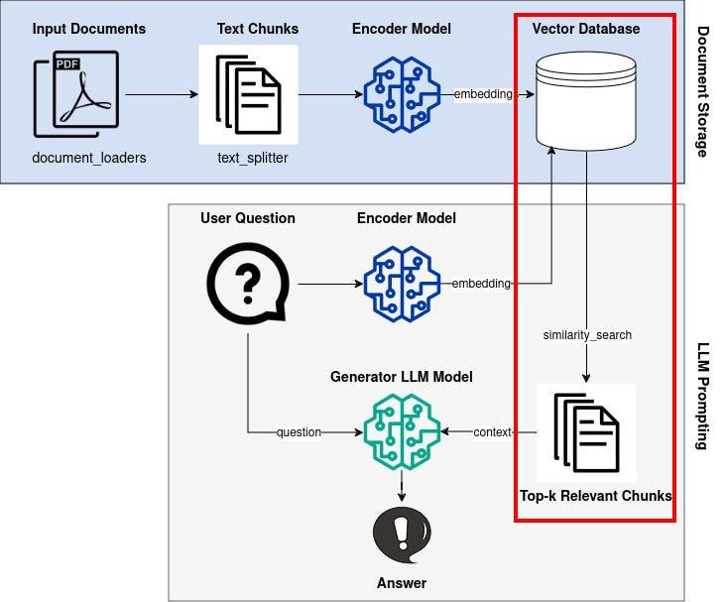

5

Architecture:
COURSE NOTES
↓
Text Extraction
↓
Chunking
↓
Embeddings
↓
Vector Database
↑
│
USER QUERY → Query Embedding
↓
Similarity Search
↓
Relevant Note Chunks
↓
LLM / RAG
↓
GROUNDED ANSWER
↓
Source / Context Display
5. Rubric-Based Implementation
Criterion | Weight | What to demonstrate for Level 4
Pipeline Functionality | 30% | Working embeddings, retrieval, vector database and generation pipeline
Answer Relevance & Groundedness | 25% | Answers directly supported by the course notes
Query Robustness | 20% | Handles different questions and different topics from the notes
End-to-End Demo | 15% | Upload → process → ask → retrieve → answer works smoothly
Architecture Explanation | 10% | Clear architecture diagram and explanation of each component
Total | 100% | Level 4 – Exemplary
6. Demo Flow
- Upload the Operating Systems course notes.
- System extracts the text.
- Text is divided into chunks.
- Generate embeddings for each chunk.
- Store embeddings in a vector database.
- Enter a question such as “Explain FIFO page replacement.”
- Retrieve the most relevant sections.
- Generate an answer using the retrieved sections.
- Display the answer + source/context.
- Test different questions to demonstrate robustness.

7. Technologies
- Python – main programming language
- LangChain – RAG pipeline
- Sentence Transformers – embeddings
- ChromaDB / FAISS – vector database
- LLM – answer generation
- PyPDF – PDF text extraction
- Streamlit – simple user interface

8. Level-4 Output Example
Question:
What is FIFO page replacement?
Retrieved Context:
Relevant section from the supplied Operating Systems notes about FIFO page replacement.
Generated Answer:
FIFO (First-In, First-Out) page replacement removes the page that has been present in memory for the longest period. Pages are maintained in the order in which they entered memory. When a page fault occurs and no free frame is available, the oldest page is replaced.
Source:
Operating_Systems_Notes.pdf → Page Replacement → FIFO
This demonstrates retrieval + grounded generation, which directly addresses the 30% Pipeline Functionality and 25% Answer Relevance & Groundedness criteria.

5)
1. Aim
- Develop a RAG-based Employee Policy Question Answering System.
- Allow employees to ask questions about company policies.
- Provide answers based only on the supplied employee policy document.
- Reduce incorrect or hallucinated answers by retrieving relevant policy sections.
2. Topics Covered
The system should answer questions about:
- Leave policies
- Working hours
- Attendance
- Holidays
- Employee benefits
- Leave eligibility
- Working-from-home rules
- Late attendance
- Public holidays

3. RAG Pipeline
EMPLOYEE POLICY PDF
↓
Text Extraction
↓
Chunking
↓
Text Embeddings
↓
Vector Database
(ChromaDB)
↑
│
Employee Question
↓
Query Embedding
↓
Similarity Search
↓
Relevant Policy Chunks
↓
LLM / Generator
↓
Grounded Answer
↓
Source / Reference
4. Example Questions
Employee Question | Expected System Response
How many paid leaves are available per year? | Retrieves the leave policy and provides the permitted number of paid leaves.
What are the working hours? | Retrieves the working-hours section and explains the required schedule.
What happens if I am late to work? | Retrieves the attendance policy and explains the applicable rule.
How many holidays are provided? | Retrieves the holiday policy and gives the number/list of holidays mentioned.
What employee benefits are available? | Retrieves the benefits section and summarizes the available benefits.
Can I work from home? | Retrieves the relevant WFH policy and explains the eligibility/rules.
For the actual project, the answers must come from the supplied employee policy document rather than being hard-coded.

5. Rubric-Based Implementation
Criteria | Weightage | Level 4 – What to Demonstrate
Pipeline Functionality | 30% | Working document processing, embeddings, vector database, retrieval and LLM generation
Answer Relevance & Groundedness | 25% | Answers are directly supported by relevant policy sections and avoid hallucination
Query Robustness | 20% | Handles different questions about leave, attendance, holidays, working hours and benefits
End-to-End Demo | 15% | Upload document → process → ask question → retrieve → generate answer works smoothly
Architecture Explanation | 10% | Clear architecture diagram and explanation of each RAG component
Total | 100% | Level 4 – Exemplary

6. Technologies Used
- Python – Application development
- LangChain – RAG pipeline
- PyPDF – Extract text from policy PDF
- Sentence Transformers – Generate embeddings
- ChromaDB – Store and search document embeddings
- LLM – Generate answers
- Streamlit – User interface

7. End-to-End Demo
Step 1 – Upload Policy Document
Upload:
Employee_Policy.pdf
Step 2 – Process Document
The system:
- Extracts text
- Splits text into chunks
- Generates embeddings
- Stores embeddings in ChromaDB
Step 3 – Ask Question
User:
How many paid leaves can an employee take?
Step 4 – Retrieval
The system searches the vector database and retrieves the most relevant section:
Leave Policy – Paid Leave
Step 5 – Generate Answer
System:
According to the employee leave policy, eligible employees can take the number of paid leaves specified in the policy. The applicable conditions and approval requirements are also mentioned in the leave section.
Step 6 – Display Source
Answer:
[Generated policy-based answer]

Source:
Employee_Policy.pdf
Section: Leave Policy
This source display is important for demonstrating groundedness.

8. Query Robustness Testing
To achieve Level 4, test different types of questions:
Simple Query
What are the working hours?
Detailed Query
What is the procedure for applying for leave?
Conditional Query
Can an employee take leave without prior approval?
Attendance Query
What happens if an employee repeatedly arrives late?
Benefits Query
What benefits are available to full-time employees?
Holiday Query
Which holidays are provided by the company?
Unrelated Query
What is the capital of India?
For an unrelated question, the system should respond appropriately, such as:
“This information is not available in the employee policy document.”
This helps prevent hallucination and improves the Answer Relevance & Groundedness score.

9. Architecture Explanation
Document Processing Layer
- Reads the employee policy document.
- Extracts and cleans the text.
- Divides the document into manageable chunks.
Embedding Layer
- Converts each chunk into a numerical vector.
- Allows semantic similarity searching.
Vector Database
- Stores document embeddings.
- Retrieves the most relevant policy sections for a question.
Retrieval Layer
- Converts the employee's question into an embedding.
- Searches for the most relevant policy chunks.
Generation Layer
- Sends the retrieved context to the LLM.
- Generates an answer based on the retrieved policy.
User Interface
- Allows employees to upload documents and ask questions.
- Displays the answer and source information.

10. Final Level-4 Demonstration
Employee Policy Document
↓
Text Extraction
↓
Chunking
↓
Embeddings
↓
ChromaDB
↓
Employee Query
↓
Similarity Retrieval
↓
Relevant Policy Context
↓
LLM
↓
Grounded Answer + Source
Expected Result
Input:
What are the working hours?
Output:
Answer: According to the Employee Policy Document, the standard working hours are as specified in the Working Hours section. Employees are expected to follow the prescribed schedule and attendance requirements.
Source: Employee_Policy.pdf → Working Hours Policy
This project structure directly targets Level 4 – Exemplary (100%) across all five rubric criteria.

